Screenshots

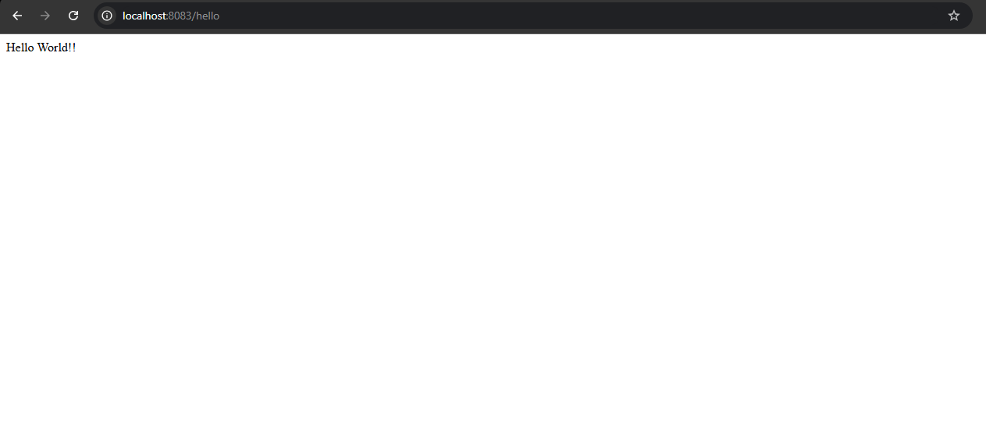

# 🌐 Hello World RESTful Web Service (Spring Learn)

## 📄 Description

This simple Spring-based RESTful web service demonstrates how to create a basic HTTP `GET` endpoint using the **Spring Web** module. The service is part of the `spring-learn` application and is designed to return the plain text message `"Hello World!!"` when accessed.

The endpoint acts as an introductory example of how Spring handles RESTful requests and responses using annotations such as `@RestController` and `@GetMapping`.

### ✅ Endpoint Details

| Method | URL | Response |

|--------|--------------------------|------------------|

| GET | `http://localhost:8083/hello` | `Hello World!!` |

### 🧩 Controller Implementation

- **Package**: `com.cognizant.spring_learn.controller`

- **Class**: `HelloController`

- **Method Signature**: `public String sayHello()`

- **Method Logic**: Returns a hard-coded string `"Hello World!!"`

The method includes debug-level logging for both **start** and **end** of execution using a logger.

### 🎯 Features Covered

- Creating a REST controller using `@RestController`

- Mapping HTTP GET requests using `@GetMapping`

- Logging method entry and exit using SLF4J `Logger`

- Testing the endpoint via **browser** and **Postman**

### 🔍 HTTP Header Observations

- When tested in **browser**, open **Developer Tools → Network tab → hello request** to inspect HTTP headers (e.g., status, content-type, content-length).

- When tested in **Postman**, switch to the **Headers** tab in the response section to view the full list of response headers sent by the Spring server (e.g., server, date, connection, etc.).